Multiple choice section – choose the correct answer

Question 1 [7.1]

Questions 1 and 2 refer to the following diagram.

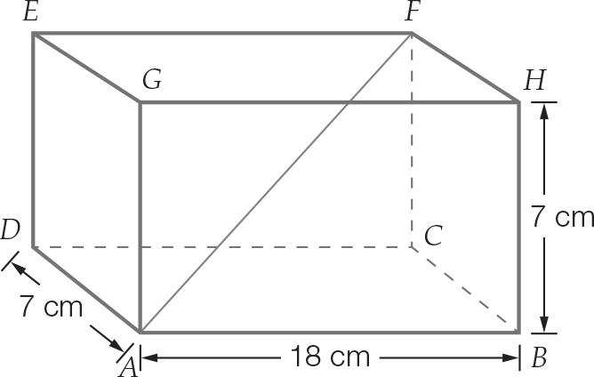

The length from A to C is closest to:

A 8 cm B 21 cm C 19 cm D 16 cm

Question 2 [7.1]

The length from A to F is closest to:

A 19 cm B 20 cm C 17 cm D 15 cm

Question 3 [7.2]

The equivalent trigonometric ratio in quadrant 1 of tan (347) is:

A tan (13) B tan (43) C −tan (13) D −tan (43)

Question 4 [7.2]

The amplitude and period respectively of the graph is:

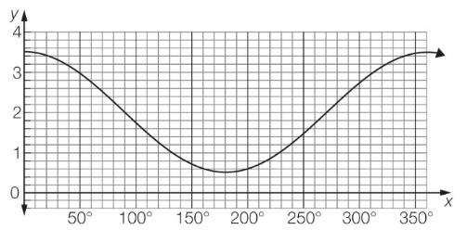

A 2, 180 B 2, 360 C 1.5, 180 D 1.5, 360

Question 5 [7.3]

The solution to  for 270 ≤ x ≤ 360 is:

A 345 B 315 C 225 D 245

Question 6 [7.4]

A triangular shade is to be erected over a sandpit between posts as shown below. The exact distance between the posts along the side marked x is:

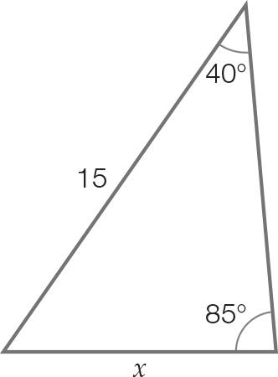

A  B 15 sin (40) sin (85) C  D 15 sin (85)

Question 7 [7.6]

Which of the following equations could not be used in relation to this triangle?

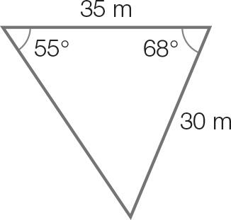

A b2 = 302 + 352 – 2 × 30 × 35 × cos (68) B Area = ½ × 30× 35 × 55

C  D C = 180 − (55 + 68)

Question 8 [7.6]

Using , the area of the shape is closest to:

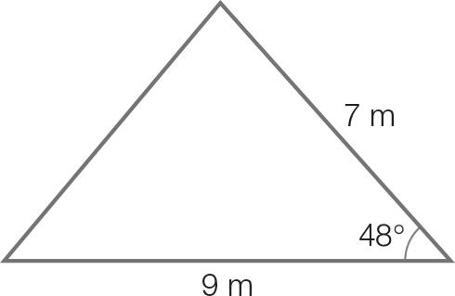

A 63 cm2 B 31.5 cm2 C 23 cm2 D 47 cm2

Multiple-choice total marks: ___ / 8

Short answer section

Question 9 4 marks [7.1]

A right pyramid ABCDE stands on a rectangular base of length 10 cm and width 14 cm. The height of the pyramid is 18 cm.

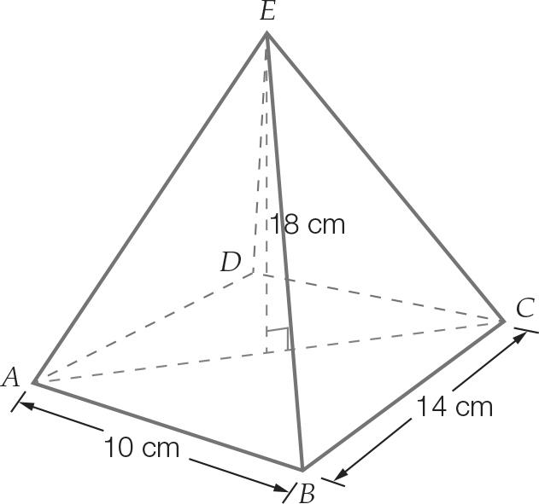

(a) Calculate the distance from A to C. Write your answer, correct to the nearest centimetre.

(b) Calculate the angle that the sloping edge makes with the base. Write your answer to the nearest degree.

Question 10 2 marks [7.1]

Calculate the diameter of the base of this cone. Leave your answer in terms of *x* and θ.

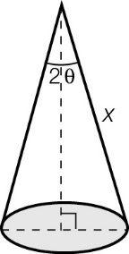

Question 11 2 marks [7.1]

Use BCD to find the angle diagonal CD makes with the base of the prism. Give your answer correct to the nearest degree.

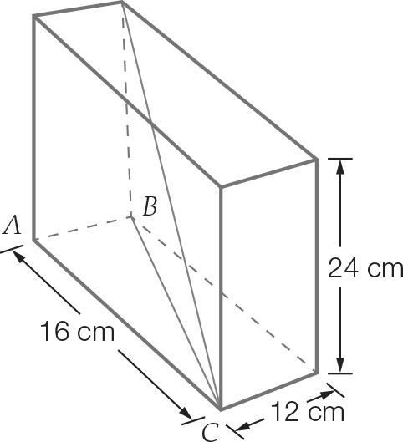

Question 12 2 marks [7.2]

For each of the following, find the equivalent trigonometric ratio in the 1st quadrant of

(a) sin (141)

(b) tan (314)

Question 13 2 marks [7.3]

In which quadrants will the solutions for the equation 3 cos (x – 2) = 0 for 0 ≤ x ≤ 360 be found? Explain your reasoning.

Question 14 2 marks [7.2]

The trigonometric ratio sin (φ) is equivalent to −sin (45). What are the possible values for angle φ that will produce this result if 0 < φ < 360?

Question 15 2 marks [7.3]

Find all solutions to the equation for 0 ≤ θ ≤ 360.

Question 16 4 marks [7.4]

For the triangle shown:

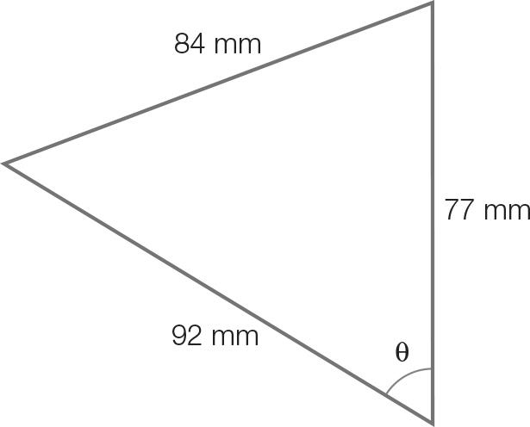

(a) find the value of the angle θ, using the cosine formula c2 = a2 + b2 – 2ab cos (θ)

(b) calculate the values of the remaining two angles.

Question 17 6 marks [7.5]

An aircraft descends at an angle of depression of 50 for a distance of 40 km. It then flies horizontally for a further 20 km.

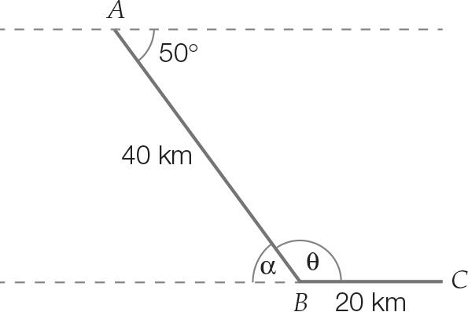

(a) Find the values of angle α and angle θ.

(b) Find the length of AC, correct to 3 decimal places.

(c) How many metres would be saved if the aircraft flies directly from A to C?

Question 18 2 marks [7.6]

Calculate the area of the triangle, correct to 2 decimal places.

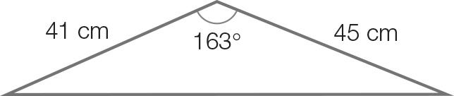

Short answer total marks: ___ / 28

Extended response section

Question 19 8 marks [7.6]

A triangular wetland is to be created with one side of length y and a second side  
of length 8y, where y is measured in metres. If the angle opposite the longer of  
these two sides is 140:

(a) draw a diagram to represent this wetland area

(b) find the size of the angle included between these sides, correct to the nearest degree

(c) write an expression for the area of the triangle

(d) find the value of y, correct to the nearest metre, if the wetland covers an area of   
 69 500 m2.

Question 20 10 marks [7.6]

An irregular shaped block of land has the dimensions shown.

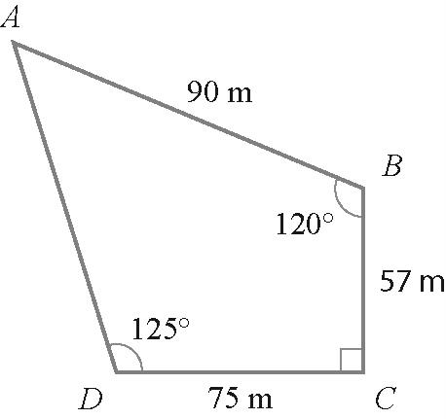

(a) There is an underground cable from B to D. What is its length, correct to the nearest metre?

(b) To the nearest degree, find and .

(c) Use the sine rule and the angles calculated in part (b) to calculate the length AD to the nearest metre.

(d) Calculate the area of and. Hence, state the area of the block to the   
nearest m2.

(e) A fence will be built along the block’s perimeter. How many metres of fencing will be needed to ensure the entire area is enclosed?

Question 21 4 marks [7.2, 7.3]

The graph shows the water level (y metres) of the sea above a high tide/low tide marker on the pier over a period of 24 hours (x-axis). The value x = 0 corresponds to 12 midnight Sunday.

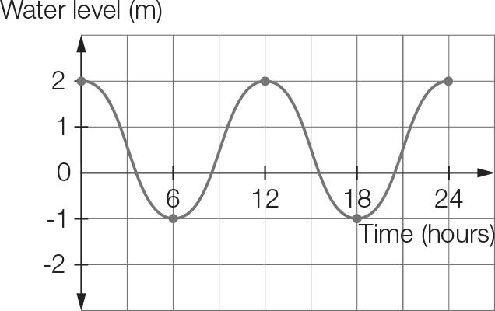

(a) Write the period and the amplitude.

(b) When is high tide during the first 12 hours?

Extended answer total marks: ___ / 22

TOTAL test marks: ___ / 58